Import Data using Transform Maps (Spreadsheet)

Phase-5 -- Project Development Phase

Date | 30/09/2026
Team Id | SWTID-2026-4384
Project Name | Import Data using Transform Maps (Spreadsheet)
Project Guide Name | Mr.M.Salaimani M.Sc.,M.Phil.

Team Leader :

  - Azhagubhuvaneshwari G - bhuvaniganeshan2007@gmail.com

Team Members :

  - Mathumithral B S - mathumithral2006@gmail.com
  - Krishnaveni S - krishnaveni1522007@gmail.com
  - Sivadhurkka K - ksivadhurkka@ gmail.com

Project Development Overview
This phase converts planned concepts into concrete ServiceNow configuration and testing steps. Activities focus on development artifacts and their verification rather than planning decisions.

  - Develop employee data import solution using Import Set / Transform Map.
  - Create target table: Employee Test (u_employee_test).
  - Create staging table: Employee Import (u_employee_import).
  - Prepare and load the spreadsheet (Sample Spreadsheet.xlsx, Sheet 1, header row 1).
  - Configure Transform Map and source-to-target mappings.
  - Enable Coalesce on Employee ID to prevent duplicates.
  - Execute transform and validate inserted/updated records.
  - Develop reports and assemble Employee Analytics Dashboards.
  - Develop the Employee Test table with the required employee fields.
  - Develop the Employee Import table as the staging area for incoming spreadsheet records.
  - Prepare employee data with Employee ID, Employee Name, Email, Department, and Location.
  - Load spreadsheet rows into the Import Set staging table.
  - Verify that the imported staging records are available before transformation.
  - Configure source-to-target mappings between the Import Set and Employee Test tables.
  - Review the Transform Map configuration before executing the transformation.
  - Test new and existing Employee IDs to verify insert and update behavior.
  - Review transformation results to identify inserted, updated, and ignored records.
  - Verify the final employee data through reports and the centralized dashboard.

Development Environment and Project Setup
Set up a controlled ServiceNow development environment and verify prerequisites before configuration.

- Obtain a ServiceNow development/learning instance.
- Ensure user account with roles to create tables, import sets, and reports (admin or equivalent).
- Open the Data Import / Load Data module in the instance.
- Prepare Sample Spreadsheet.xlsx (Sheet 1, header row 1) on the local workstation.
- Create placeholders for u_employee_import and u_employee_test or confirm they do not conflict with existing objects.
- Confirm availability of Import Set framework and Transform Map functionality.
- Verify that the ServiceNow instance is accessible before beginning development.
- Confirm that the required employee data import functionality is available.
- Prepare the spreadsheet file for the development import.
- Verify that Sheet 1 contains the employee data.
- Confirm that row 1 contains the spreadsheet column headers.
- Verify the five required employee fields: Employee ID, Employee Name, Email, Department, and Location.
- Check that the planned Employee Import staging table can be used for incoming data.
- Check that the planned Employee Test table can be used as the target for transformed records.
- Confirm that the development environment is ready for Transform Map configuration and data transformation.
- Verify the environment before proceeding to table creation, data import, transformation, and testing.

Employee Test Table Development
Develop the target table that will store transformed employee records. Keep schema minimal and aligned with source fields to simplify mapping and validation.

  - Label: Employee Test
  - Table name: u_employee_test
  - Fields to create:
    - Employee ID — String
    - Employee Name — String
    - Email — String
    - Department — String
    - Location — String
  - Set appropriate field lengths and required flags where necessary (e.g., Employee ID required).
  - Document table and field definitions for project records.


Create Employee ID
Create Employee Name
Create Email
Verify Target Table

Employee Import Staging Table Development
Create the Import Set staging table to receive raw spreadsheet rows. Use this table as the Transform Map source to ensure controlled transformation.

  - Label: Employee Import
  - Table name: u_employee_import
  - Define source fields to match spreadsheet headers: Employee ID, Employee Name, Email, Department, Location.
  - Use the staging table only for raw data; do not add business logic or derived fields here.
  - Verify the table is available in the Load Data wizard before uploading the spreadsheet.

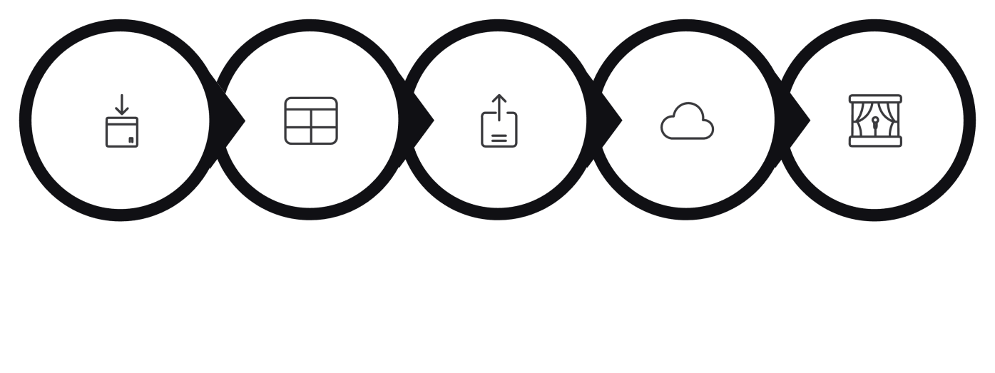
Create Import
Prepare Fields
Upload Sheet
Load Data
Import Staging

  - Create the Employee Import table as the staging area for incoming employee spreadsheet data.
  - Configure the table name as u_employee_import.
  - Prepare the five source fields required for the employee import.
  - Maintain Employee ID as part of the source data for record identification.
  - Include Employee Name as a source field for employee information.
  - Include Email as a source field for employee contact information.
  - Include Department as a source field for department-based reporting.
  - Include Location as a source field for location-based reporting.
  - Verify that the staging table can receive the spreadsheet records before transformation.
  - Confirm that the Employee Import table is ready to act as the source table for the Sample
Spreadsheet Import Transform Map.

Spreadsheet Data Development
Prepare a controlled sample spreadsheet for development and test imports. Include examples to exercise insert, update, and ignored outcomes.

  - File name: Sample Spreadsheet.xlsx
  - Sheet: Sheet 1; Header row: Row 1
  - Columns required: Employee ID, Employee Name, Email, Department, Location
  - Create sample rows including:
    - Two new Employee IDs (for insert testing).
    - Two existing Employee IDs with modified fields (for update testing).
    - Rows that will be re-imported to verify idempotency.
  - Save and retain the spreadsheet for repeated import tests.


Prepare Employee
Data
Ready for Import
Spreadsheet.
Sample
xlsx

  - repare the spreadsheet using a consistent column structure.
  - Keep Employee ID available for every test record.
  - Use unique Employee IDs for the new-record test cases.
  - Use existing Employee IDs for the update test cases.
  - Change employee information such as Employee Name or Email for update testing.
  - Keep Department values available for department-based report testing.
  - Use the prepared spreadsheet as the common input for Import, Transform, Insert, Update, and Ignore validation.

Import Set Development
Perform the Import Set steps to load spreadsheet records into the staging table prior to transformation.

  - Open Load Data (Data > Load Data).
  - Select Sample Spreadsheet.xlsx.
  - Choose Sheet 1 and specify Row 1 as header row.
  - Map the spreadsheet to the Import Set table u_employee_import (create a new import set if required).
  - Execute the load and confirm the Import Set shows the expected number of rows.
  - Resolve any parsing errors before proceeding to Transform Map configuration.

Select File
Choose Sheet
Set Header Row
Load & Verify

  - Verify that Sample Spreadsheet.xlsx contains the required employee columns before loading.
  - Open the Load Data functionality to begin the spreadsheet import.
  - Select the prepared spreadsheet as the import source.
  - Select Sheet 1 from the spreadsheet.
  - Set Row 1 as the header row.
  - Confirm that the spreadsheet columns are recognized correctly during loading.
  - Use Employee Import (u_employee_import) as the staging table.
  - Verify that the uploaded spreadsheet rows are available in the staging table.
  - Confirm that the Import Set completes successfully before transformation.
  - Review the loaded data before running the Sample Spreadsheet Import Transform Map.

Transform Map Development
Configure the Transform Map to move data from the staging table to the Employee Test table. Use Auto Map and Mapping Assist for accuracy, then save and prepare for transformation execution.

  - Transform Map Name: Sample Spreadsheet Import
  - Source Table: u_employee_import
  - Target Table: u_employee_test
  - Configure mappings:

- Employee ID → Employee ID
- Employee Name → Employee Name
- Email → Email
- Department → Department
- Location → Location

  - Use Auto Map Matching Fields for exact header matches; use Mapping Assist for manual mapping corrections.
  - Review and save the Transform Map; document the mapping definitions.
  - Create the Transform Map after the Employee Import staging table is available.
  - Set Sample Spreadsheet Import as the Transform Map name.
  - Select u_employee_import as the source table.
  - Select u_employee_test as the target table.
  - Verify that the source fields are available for mapping.
  - Verify that the corresponding target fields are available in Employee Test.
  - Map Employee ID from the source field to the target Employee ID field.
  - Map Employee Name, Email, Department, and Location to their corresponding target fields.
  - Review all field mappings before saving the Transform Map.
  - Save the completed Transform Map and prepare it for the Transform operation.

Coalesce Development
Enable Coalesce on Employee ID to ensure proper insert/update behavior. Test with both existing and new IDs to confirm deduplication and intended outcomes.

  - Identify Employee ID as the Coalesce field in the Transform Map field map.
  - Enable the Coalesce option for the Employee ID mapping.
  - Save the mapping and the Transform Map.
  - Test scenarios:

- Import row with existing Employee ID → record should update.
- Import row with new Employee ID → record should insert.

  - Use transformation logs to confirm which records were Inserted, Updated, or Ignored.

Update Record
Modify existing employee
Insert Record
Create new employee entry
Is ID Existing?
Determine record presence

Check Employee ID
Verify incoming ID value

- Data Transformation, Testing, Reports, Dashboard & Verification
This section summarizes execution of transforms, testing scenarios, report development, dashboard composition, and final verification steps required to complete development.

Data Transformation
Execute the Transform operation after confirming Import Set contents. Verify fields map correctly and Coalesce behavior is applied.

Testing & Validation
Run test scenarios: initial import, mixed new/existing rows (2 new, 2 existing), and repeated import to confirm idempotency and duplicate prevention. Validate transformation history and resulting Employee Test records.

Report Development
Create three reports sourced from Employee Test: (1) Employees by Department (pie, count), (2) Employees by Location (bar, count), (3) Employee List (list with specified columns).

Dashboard Development
Assemble Employee Analytics Dashboards with the three reports. Arrange components for quick visibility and configure sharing to required users/groups/roles.

Development Verification
Confirm completion: tables created, spreadsheet loaded, Transform Map saved, Coalesce functioning, transforms validated, reports and dashboard created, final records verified.
Staging
Transform Map
Field Mapping
Coalesce Check

Testing Matrix (Concise)

Scenario | Expected Outcome
Initial Import (4 rows) | Records inserted into u_employee_test per Coalesce rules
2 New + 2 Existing | 2 Inserted, 2 Updated
Re-import Same File | 0 Inserted, 0 Updated, existing rows Ignored
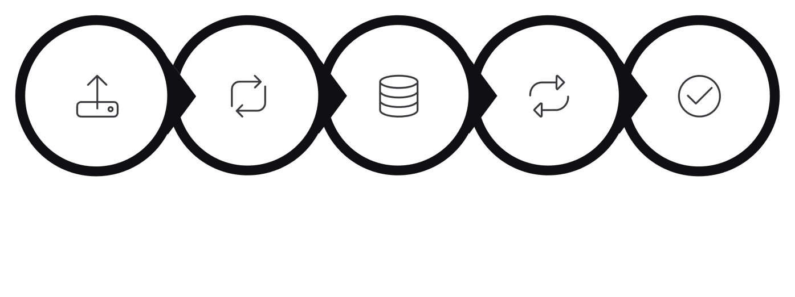
Upload 4 Rows
Transform
Insert 2 /
Update 2
Repeat Same File
0 Insert / 0 Update

